**ASSIGNMENT-1**

**By**

***Name:-Shivam Raina***

**Roll No:-167**

**Sem:-1st**

**Department:-CSE**



**Model Institute of Engineering & Technology (Autonomous)**

(Permanently Affiliated to the University of Jammu, Accredited by NAAC with “A” Grade)

Jammu, India

2023



Q1. Write a C program to count the number of words in a string.

#include <stdio.h>

#include <string.h>

// Function to count the number of words in a string

int countWords(char *str) {

    int count = 0;

    int flag = 0;

    for (int i = 0; str[i] != '\0'; i++) {

        if (str[i] == ' ') {

            if (flag == 1) {

                count++;

            }

            flag = 0;

        } else {

            flag = 1;

        }

    }

    if (flag == 1) {

        count++;

    }

    return count;

}

int main() {

    char str[1000];

    printf("Enter a string: ");

    fgets(str, sizeof(str), stdin);

    // Remove newline character from the string

    str[strcspn(str, "\n")] = '\0';

    int wordCount = countWords(str);

    printf("Number of words in the string = %d\n", wordCount);

    return 0;

}

Output:- PS C:\Users\HP\New folder\system.c> cd "c:\Users\HP\New folder\system.c\" ; if ($?) { gcc assignment.c -o assignment } ; if ($?) { .\assignment }

Enter a string: 34667889

Number of words in the string = 1

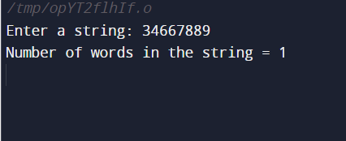

Q2. Write the program to change all the first letters as Caps in sentance.

Eg: i am studying at miet

Output: I Am Studying At Miet

#include <stdio.h>

#include <ctype.h>

#include <string.h>

void capitalize_first_letter(char *sentence) {

for (int i = 0; i < strlen(sentence); i++) {

if (i == 0 || sentence[i - 1] == ' ') {

sentence[i] = toupper(sentence[i]);

}

}

}

int main() {

char sentence[] = "i am studying at miet.";

capitalize_first_letter(sentence);

printf("%s\n", sentence);

return 0;

}

Output:- PS C:\Users\HP\New folder\system.c> cd "c:\Users\HP\New folder\system.c\" ; if ($?) { gcc assignment.c -o assignment } ; if ($?) { .\assignment }

I Am Studying At Miet.

